ITA0305- Mobile Computing
LAB EXPERIMENT
Name: G.Ganesh
Reg NO:192373008

17. Create an error alert UI for connection drops.
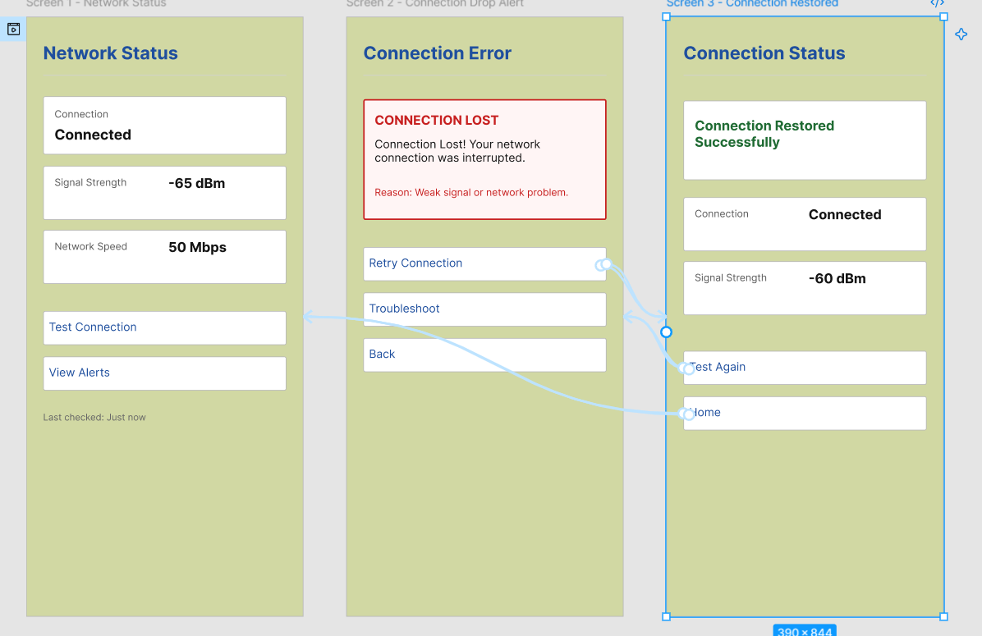

https://www.figma.com/design/HxJmzmXFsrScpBsUzfRwwy/program17?node-id=1-122&t=plOxX4rs2j7pNYYu-0

